Instruction to obtain the security certificate

After setting up the dotBank Client system, you need to request the user's security certificate.
Step 1:
Go to the following link to initiate the certificate generation procedure:
https://client.dotbank.md:4443/certsrv/certrqma.asp
Step 2:
When a new window appears, press the "Yes" button, as shown in the picture below.
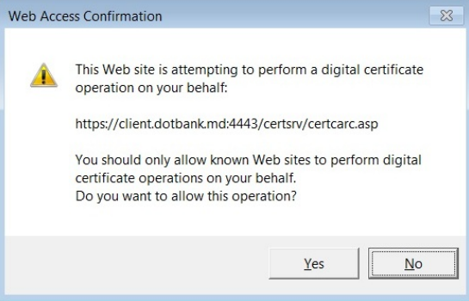
Step 3:
In the next window, it is necessary to fill in the required fields in the following way:
- The "Name" field - you must enter the first and last name of the person for whom the certificate is requested (e.g., Ion Tonu). If a person has the right to sign with both signatures, then in "Name" field it is necessary to enter the letter "D" for the signature of the director and the letter "C" for the accountant's signature (eg, Ion Tonu D or Ion Tonu C). The "Name" field must be strictly according to the request for access to the Client dotBank system.
- The "Email" field - you must enter the address of the mailbox strictly according to the request for access to the Client dotBank system.
- The "Company" field - you must enter the full company name, strictly according to the request for access to the Client dotBank system.
- The "Department" field - you must enter the position held by the person for whom the certificate is requested (eg, Director or Contabil).
- The "City" field - enter the name of the city where the company operates/activates.
- The "State" field - you must enter the country in which the company operates/activates.
- The "Country / Region" field - you must enter the MD abbreviation(as shown in the image below).
WARNING: The fields "Name", "E-mail", "Company" and "Department" must be filled in strictly according to the request for access to the Client.dotBank system.

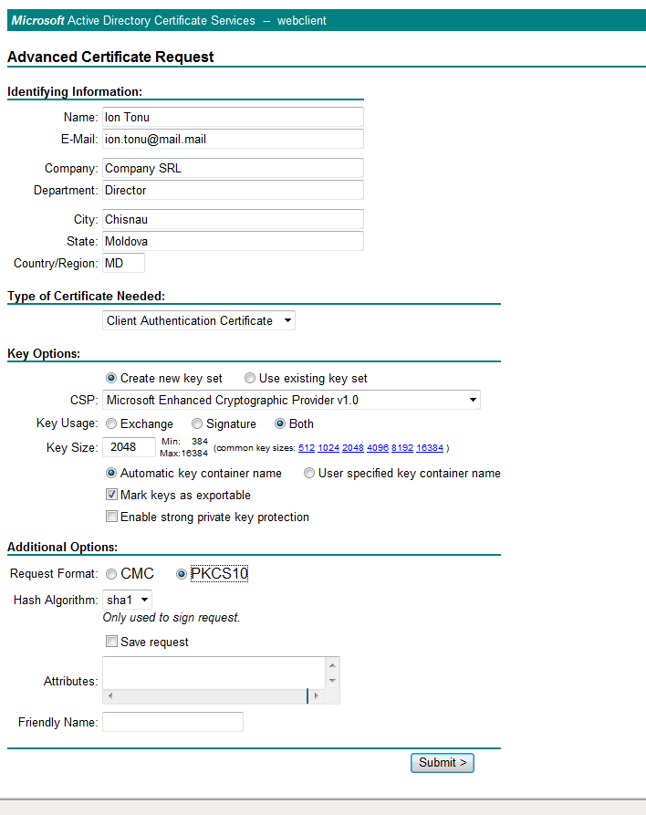

Step 4:
To send the request to the server, you must:
- In the CSP field select the "Microsoft Enhanced Cryptographic Provider v1.0"
- Mark the "Mark keys as exportable"
- Select the PKCS10 option
- Press the Submit button.
Step 5:
After you click on the Submit button, the system will generate a new window (as shown in image below) that displays a message that your request has been sent to the administrator.
Once the application has been received, the administrator will issue the required certificate within one working day.
