Instruction for setting up the VB24 Business Client system

Step 1:

Go to the following link to download the app:
Application for operating systems Windows 7, 8, 10:
https://www.victoriabank.md/VB24/VB24_Business.exe

Step 2:

Save the application to your computer and then launch the app.

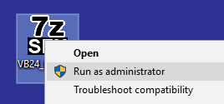

Step 3:

Once you have clicked on "Run as administrator", a new window will appear with two options (as shown in image below). You must press the "Yes" button.

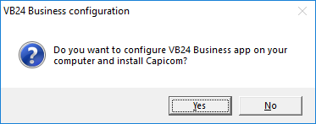

Step 4:
In the next window choose the "Yes" option.

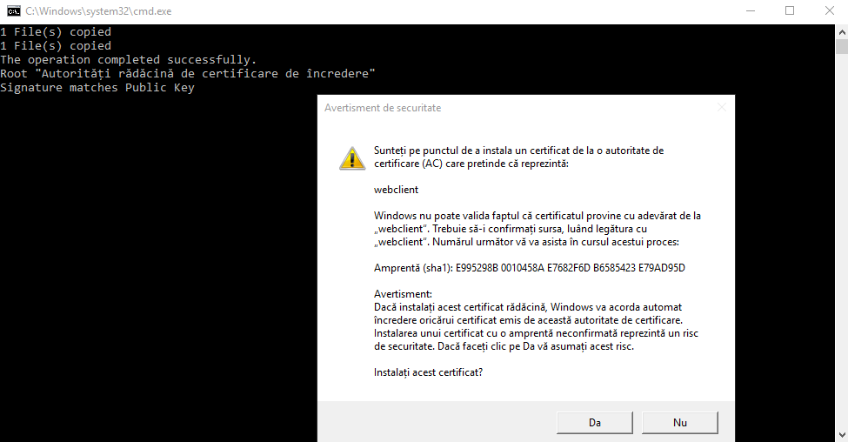

Step 5:
In the window that appears click the "OK" button.

